38.46: (a) Wien’s law: 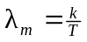
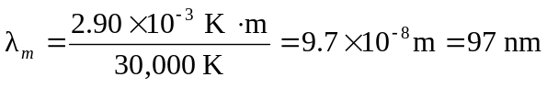
This peak is in the ultraviolet region, which is not visible. The star is blue because the largest part of the visible light radiated is in the 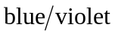part of the visible spectrum
(b) 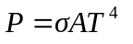(Stefan-Boltzmann law)

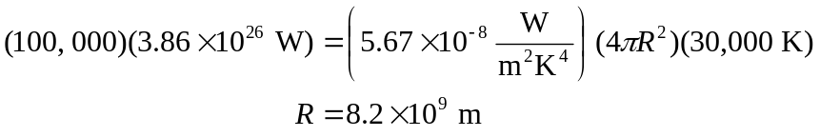
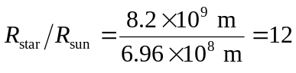
(c) The visual luminosity is proportional to the power radiated at visible wavelengths. Much of the power is radiated nonvisible wavelengths, which does not contribute to the visible luminosity.

